**Seattle vs New Orleans: A Comparison of Rainfall Patterns (2018–2022)**

# **Introduction**:

This report compares rainfall patterns in Seattle, WA, and New Orleans, LA, using daily precipitation data from 2018–2022. The goal is to describe how often it rains, how rainfall amounts differ between the two cities, and what seasonal patterns appear in each. The analysis uses simple averages and visual summaries to communicate results to a general audience. Comparing these two distinct climates, one in the Pacific Northwest and one in the Gulf Coast, illustrates how geography influences rainfall behavior.

# **Data**:

The datasets include daily precipitation records from weather stations in Seattle and New Orleans from January 2018 to December 2022. Each record reports daily precipitation (PRCP) along with other weather attributes. The data were cleaned, sorted by date, and analyzed separately for each city to identify trends, averages, and frequency of rainy days.

# **Methods**:

For each city, daily precipitation values were used to calculate 30-day moving averages, monthly totals, and the number of wet days per month (days with more than zero precipitation). A histogram was also used to show how often light versus heavy rainfall occurred. The same analysis steps were applied to both datasets to allow for a fair comparison.

**Results:**

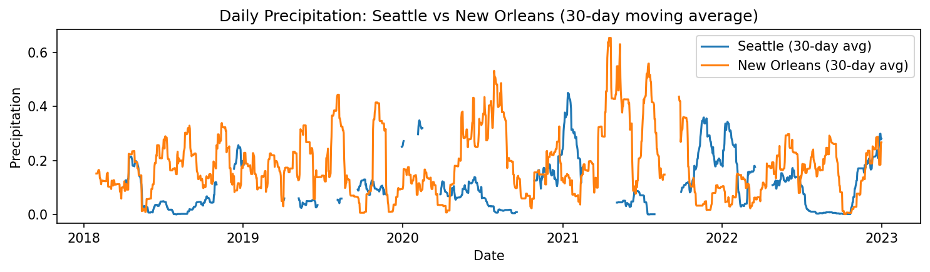

**Figure 1.** Daily precipitation with a 30-day moving average.

Seattle shows frequent small rain events, while New Orleans experiences more sporadic but intense rainfall.

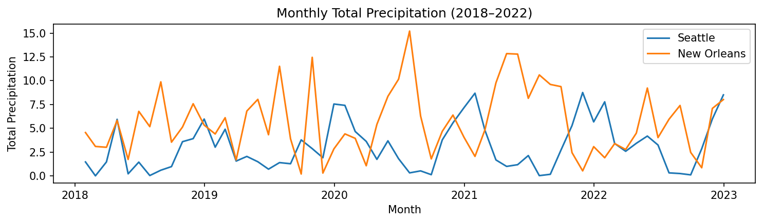

**Figure 2.** Monthly total precipitation.

Both cities receive substantial rainfall, but Seattle’s totals are spread across more months, whereas New Orleans peaks sharply in summer.

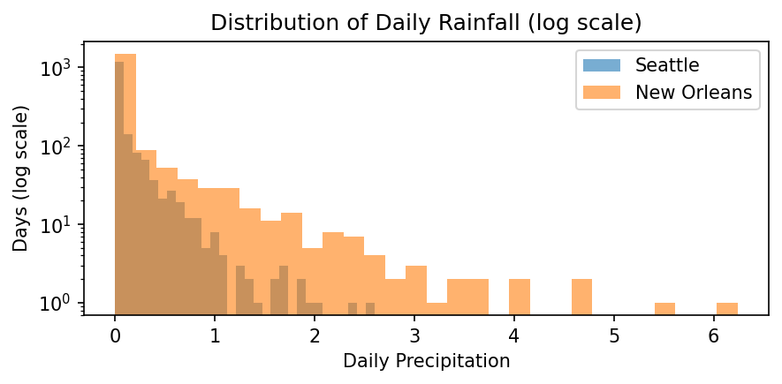

**Figure 3.** Distribution of daily precipitation (log scale).

Seattle has many light-rain days, while New Orleans has fewer but heavier downpours, resulting in a more skewed distribution.

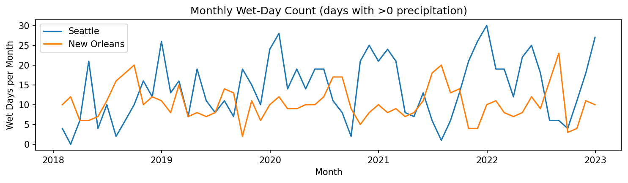

**Figure 4.** Monthly wet-day count.  
Seattle experiences rain on more days each month, but New Orleans gets fewer yet heavier rainy days.

**Conclusion**:

Seattle and New Orleans both receive substantial rainfall, but in very different ways. Seattle’s climate is characterized by frequent, light rain spread across many days, while New Orleans tends to have fewer rainy days but heavier storms, especially during late summer. These patterns reflect the Pacific Northwest’s cool marine climate and the Gulf Coast’s humid subtropical climate. A longer dataset would help confirm whether these trends have changed over time.